**Day 5**

1. GROUP BY with WHERE - Orders by Year and Quarter

Display, order year, quarter, order count, avg freight cost only for those orders where freight cost > 100

**Before running the Query:**

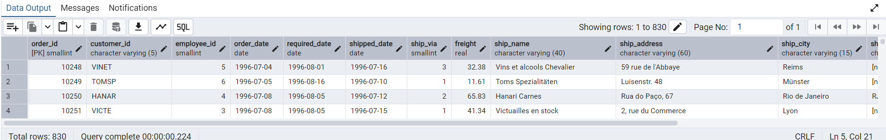

**Query:**

SELECT

EXTRACT(YEAR FROM order_date) AS order_year,

EXTRACT(QUARTER FROM order_date) AS order_quarter,

COUNT(*) AS order_count,

AVG(freight) AS freight_cost

FROM

orders

WHERE

freight > 100

GROUP BY

order_year,

order_quarter

ORDER BY

order_year,

order_quarter;

**Query Output:**

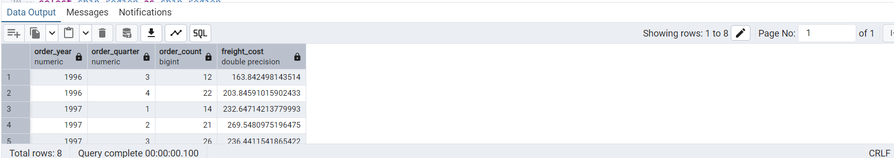

2. GROUP BY with HAVING - High Volume Ship Regions

Display, ship region, no of orders in each region, min and max freight cost  
 Filter regions where no of orders >= 5

**Before running the query:**

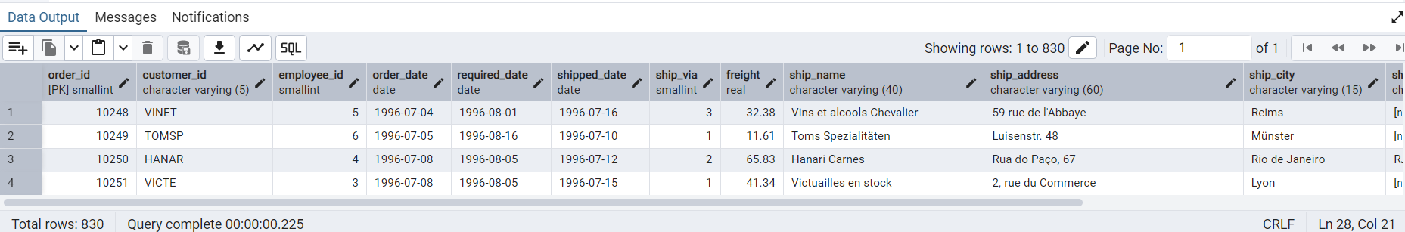

**Query:**

select ship_region as ship_region,

COUNT(*) AS order_count,

min(freight) as min_freight,

max(freight) as max_freight

FROM

orders

group by ship_region

HAVING

COUNT(*) >= 5

order BY ship_region;

**Query Output:**

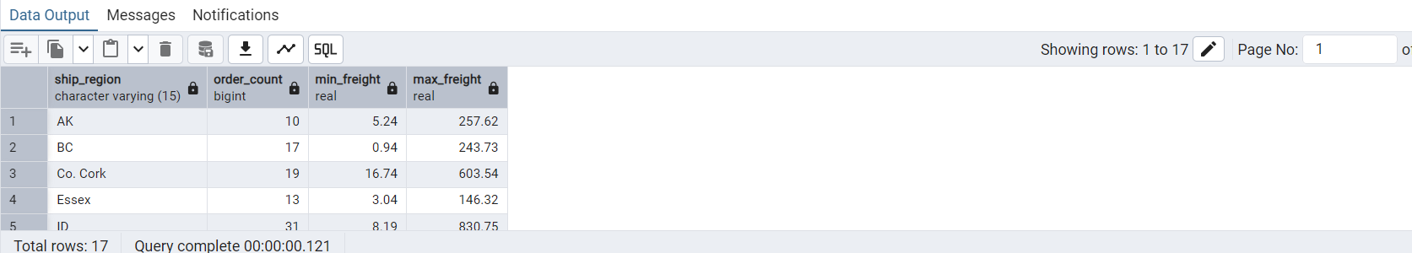

3. Get all title designations across employees and customers ( Try UNION & UNION ALL)

SELECT title AS designation

FROM employees

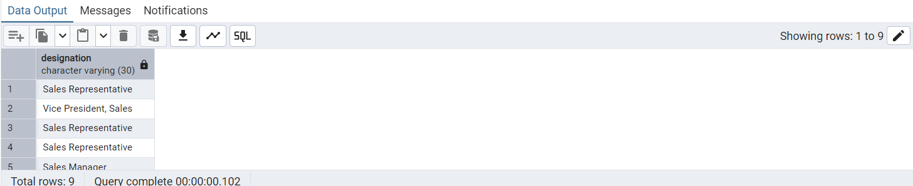

**--UNION -- UNION removes duplicates by default**

**Query:**

SELECT contact_title AS designation

FROM customers

UNION

select title as designation

from employees

**Output:**

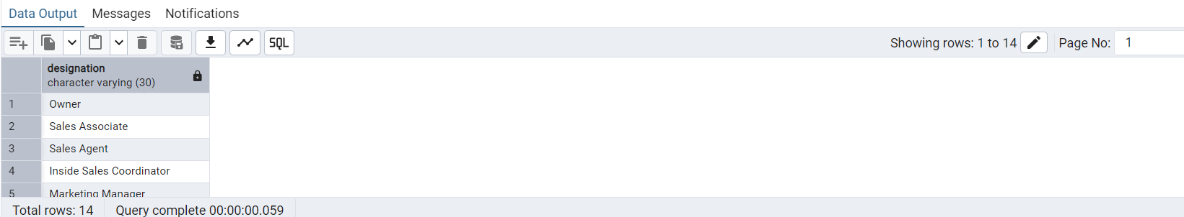

**UNION ALL -- UNION ALL includes all rows, including duplicates**

SELECT contact_title AS designation

FROM customers

UNION ALL

select title as designation

from employees

**Output:**

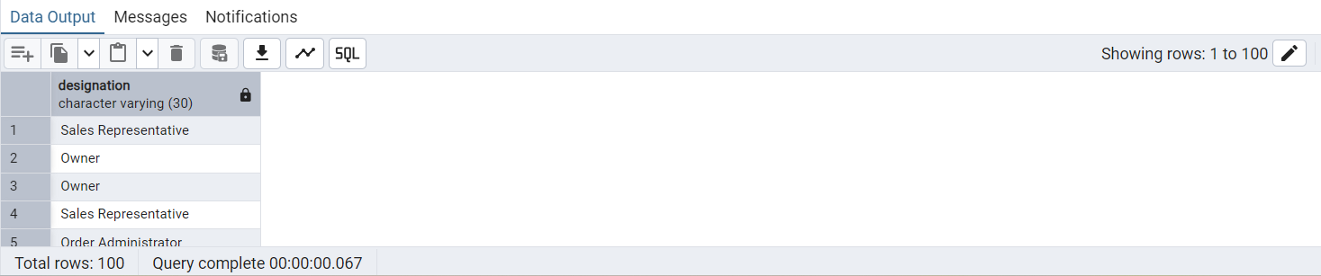

4. Find categories that have both discontinued and in-stock products

(Display category_id, instock means units_in_stock > 0, Intersect)

**Query:**

SELECT category_id,

units_in_stock as instock

FROM products

WHERE product_id IN (

SELECT product_id

FROM products

WHERE discontinued = 1

)

INTERSECT

SELECT category_id,

units_in_stock as instock

FROM products

WHERE product_id IN (

SELECT product_id

FROM products

WHERE units_in_stock > 0

);

**Output:**

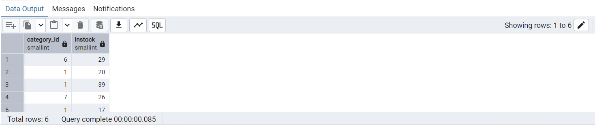

5. Find orders that have no discounted items (Display the order_id, EXCEPT)

**Query**

SELECT order_id

FROM orders

WHERE order_id NOT IN (

SELECT order_id

FROM order_details

WHERE discount > 0

);

**Output:**

